**Logical reasoning (set 3)**

**Company name: HCL No. of Question: 15**

**1:** How many meaningful English words can be made with the letters ‘ESRO” using each letter only once in each word?

1. None
2. One
3. Two
4. Three

**Answer:** option d

**Solution :**

Three meaningful words ‘ROSE’, ‘SORE’ and ‘ORES’ can be formed by using letters from ‘ESRO’.

**2:** Deepak's father was 30 years of age when he was born while his mother was 29 years old when his sister was born who is four years younger to him. What is the difference between the ages of his parents?

1. 6 year
2. 7 year
3. 4 year
4. 5 year

**Answer:** option d

**Solution :**

Mother's age when the sister of Deepak was born = 29 years

Father's age when the sister of Deepak was born = 30+4 = 34 years

Age difference = 34 - 29 = 5 years

**3:** In the following question, select the related word from the given alternatives?

Yellow : China :: Lena : ?

1. UK
2. USA
3. Russia
4. Brazil

**Answer:** option c

**Solution :**

Yellow river flow in China whereas the Lena River flows in Russia.

**4:** If "LUCKNOW" is coded as "KTAIKLS" then find the code for "BOMBAY"?

1. AJMTVT
2. ANKZXV
3. MJXVSU
4. WXYZAX

**Answer:** option b

**Solution :**

L (12 – 1) = K

U (21 – 1) = T

C (3 – 2) = A

K (11 – 2) = I

N (14 – 3) = K

O (15 – 3) = L

W (23 – 4) = S

B (2 – 1) = A

O (15 – 1) = N

M (13 – 2) = K

B (2 – 2) = Z

A (1 – 3) = X

Y (25 – 3) = V

**5:** Sarika starts moving south from point A and after 10 meters distance, she turn to the left and runs 8 meters. Again she turns to the left and moves 9 meters and reaches point B. Find the distance between point B and A?

1. 9.06 m
2. 8.06 m
3. 8.36 m
4. 7.98 m

**Answer:** option b

**Solution :**

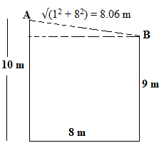

**6:** Find the best suitable relationship between Human, Women, Actress?

1. 
2. 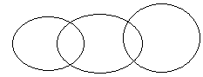
3. 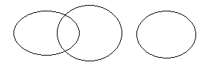
4. 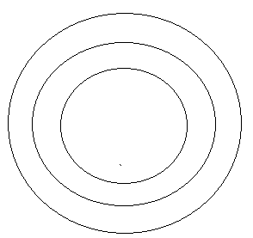

**Answer:** option d

**Solution :**

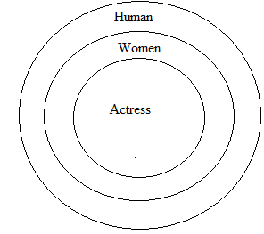

**7:** In the following question, select the related number from the given alternatives?

M : 169 :: U : ?

1. 196
2. 324
3. 256
4. 441

**Answer:** option d

**Solution :**

‘169’ is the square of the position value of letter 'M' and ’441’ is the square of the position value of the letter 'U'.

**8:** In the following question, choose the odd word from the given alternatives.

Red, Orange, Yellow, Pink, Green

1. Red
2. Orange
3. Yellow
4. Pink

**Answer:** option d

**Solution :**

All except pink are the colors seen in a rainbow.

Hence, pink is wrong.

**9:** 6 women are sitting in a circle facing center and talking to each other. F is sitting between A & B. E is sitting between C & D. D is sitting at immediate left of A. Which woman is sitting between E and B ?

1. F
2. C
3. D
4. A

**Answer:** option b

**Solution :**

According to question, seating arrangement for the 6 women will be as follows:

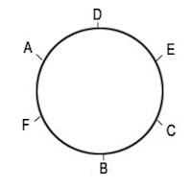

Therefore, C is sitting between E and B.

**10 :** In the following question, select the related word from the given alternatives.

Mouse : ? :: Flash: Camera

1. Rat
2. Computer
3. Cord
4. Dessert

**Answer:** option b

**Solution:**

Mouse is a part of a computer and flash is a part of a camera.

**11:** X’s mother is sister of Y and daughter of Z. S is the daughter of Y and sister of T. How is Z related to T?

1. Mother
2. Father
3. Grandmother or Grandfather
4. Sister

**Answer:** option c

**Solution:**

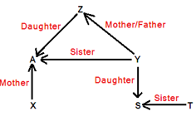

Form the above family tree it can be concluded that Z is either grandmother or grandfather of T.

**12:** Alok walked 9m towards east and took a Right turn and walked 12m. He again took a right turn and walked 15m. Towards which direction is he from his starting point?

1. South
2. West
3. South - West
4. South - East

**Answer:** option c

**Solution:**

The movement of Alok shown in figure below:

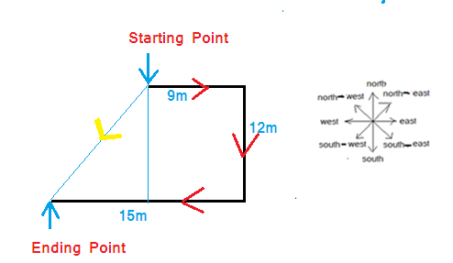

From figure, it is clear that he is in South-West direction from his starting point.

**13:** A word is represented by only one set of numbers as given in any one of the alternatives. The sets of numbers given in the alternatives are represented by two classes of alphabets as in two matrices given below. The columns and rows of Matrix I are numbered – from 0 to 4 and that Matrix II are numbered from 5 to 9. A letter from these matrices can be represented first by its row and next by its column, e.g., ‘A’ can be represented by 00, 12, 23, etc. and P can be represented by 58, 69, 75, etc. Similarly, you have to identify the set for the word ‘RENT’.

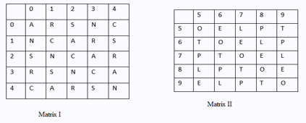

1. 01,56,21,69
2. 30,67,32,98
3. 24,78,11,59
4. 20,59,32,76

**Answer:** option b

**Solution:**

Code for R = 30,

Code for E = 67,

Code for N = 32,

Code for T = 98

**14:** Five friends A, B, C, D, E are sitting on to the ladder in such a way, A sits Above to E, D sits below to B but above D, E sits below to B and D sits above to C. Who sits at middle position in the ladder?

1. D
2. A
3. E
4. C

**Answer:** option c

**Solution:**

According to question, seating arrangement for the 5 people will be as follows:

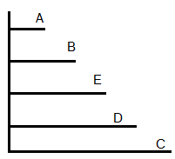

Thus, E is at the middle position in the ladder.

**15:** In following options which Venn diagram is the most suitable for Honesty, Intelligence, Aptitude ?

1. 
2. 
3. 
4. 

**Answer:** option a

**Solution:**



All are different entities.